**Kickstarter Data Analysis**

1. **Given the provided data, what are three conclusions we can draw about Kickstarter campaigns?**

Kickstarter is a crowd funding platform for creative projects - everything from film, games, and music to art, design, and technology. For this project I analyzed a database of 4,114 past Kickstarter campaigns that were launched between 2009 and 2017 to understand what increases the likelihood of a specific Kickstarter campaign being successful.

Of the 4,114 campaigns, 53% were successful in meeting their fundraising goal. The average campaign goal was $71,939 but the average pledged was $11,224. The data shows that the size of a campaign’s goal had a negative correlation to the probability of it being successful. Projects under $1,000 were successful 70% of the time, projects under $5,000 were successful 65% of the time, and projects under $10,000 were successful 53%. Conversely, based in this historical data, goals over $10,000 are more likely to fail than reach their funding amount, with goals over $50,000 only being successful 19% of the time.

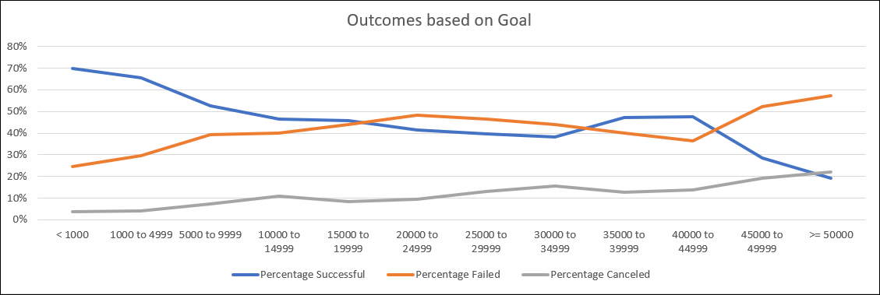

The month in which a campaign was launched also had an impact on its performance. I found that the best timeframe to launch a campaign is between February through May. May had the highest success rate of 60.62%, followed by February with a 60.3% success rate. The worst month to launch a campaign was December which had the lowest success rate of 44%

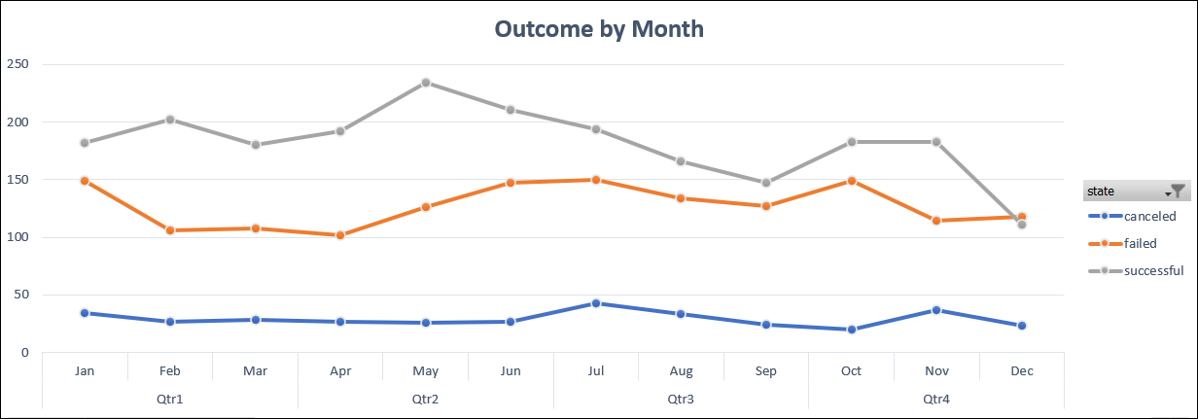

Finally, I found that the type of project launched also had an impact on its performance. Of the 700 music projects launched, 77% of them were fully funded. The only genres of music that did not perform well were faith, jazz and world music. All other genes were highly successful with the most popular being rock.

Also, the following sub-categories of projects had 100% success rate: plays, documentaries, tabletop games, hardware (technology), non-fiction and radio/podcasts (publishing).

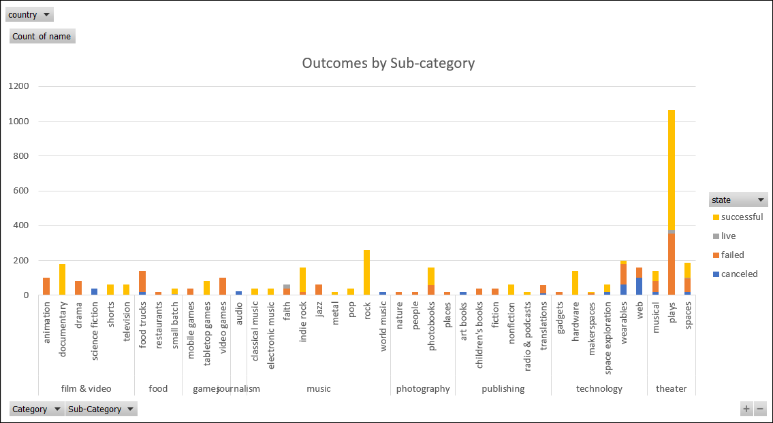

1. **What are some limitations of this dataset?**

Some of the limitations of this dataset are that it does not include recent campaign activity. It is possible that funding trends have changed in the past 4 years. I also suspect that this is not a full set of data for the 2009-2017 time frame. If this is not the full data set, I would at least want to know the true number of campaigns launched during that time frame to better understand if my data set is statistically relevant.

1. **What are some other possible tables and/or graphs that we could create?**

I would convert most of the existing charts to % rather than count to better contextualize the data. I would also like to analyze average length in days a campaign runs and if that impacts its chances for success. I would also like to dig deeper into the Staff Pick data by State to determine if there is any bias there.